**Lab – 1 Datasheet**

**CpE 4010: Sensors, Actuators and Integration**

|  |  |
| --- | --- |
| Name: Anindita Deb | KSU ID: 000922115 |

**From procedure 3:**

**Period of default sine wave_______200ns___________**

**From procedure 4:**

**Calculated Nyquist Rate_________200MHz___________**

**From procedure 6:**

**Insert your screenshot of Nyquist Rate waveform here:**

**From procedure 8:**

**Describe appearance of sampled signal with 37 MHz sampling rate here:**

**Far fewer samples are taken and it results in the right function looking extremely choppy.**

**37MHz represents the original signal far worse than the previous 200MHz sampling frequency. There is a lot more error that takes place between each sampling internal. It’s not as smooth as the previous.**

**From procedure 9:**

**Describe appearance of sampled signal with 1-bit resolution here:**

It’s completely changes the look of the sampled signal to what looks like a step function either a high or a low, no in-between.

**From procedure 11:**

**Sampling rate (frequency) to produce smooth sinusoid______500MHz___________**

The rate in step 4 was 200MHz, I’ve set the sampling frequency to 500MHz and that is 2.5 times greater than previously.

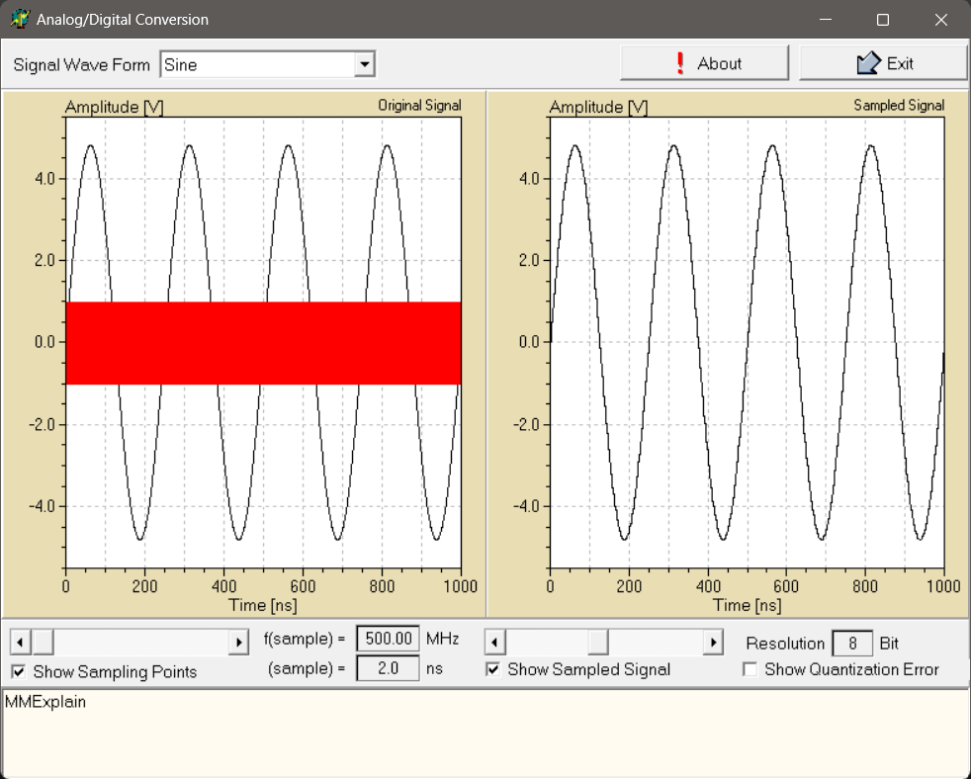

**From procedure 12:**

**Describe quantization error here:**

**Quantization error is the error that occurs when the analog signal is converted to a digital signal but is limited to the number of levels it can ultimately read into. This means that since the digital signal is being measured a certain fixed intervals the analog signal get rounded to the nearest digital value.**

**The higher bits we get higher resolution, hence lower error.**

**The lower bits, the lower resolution we have, this leads to higher quantization errors.**

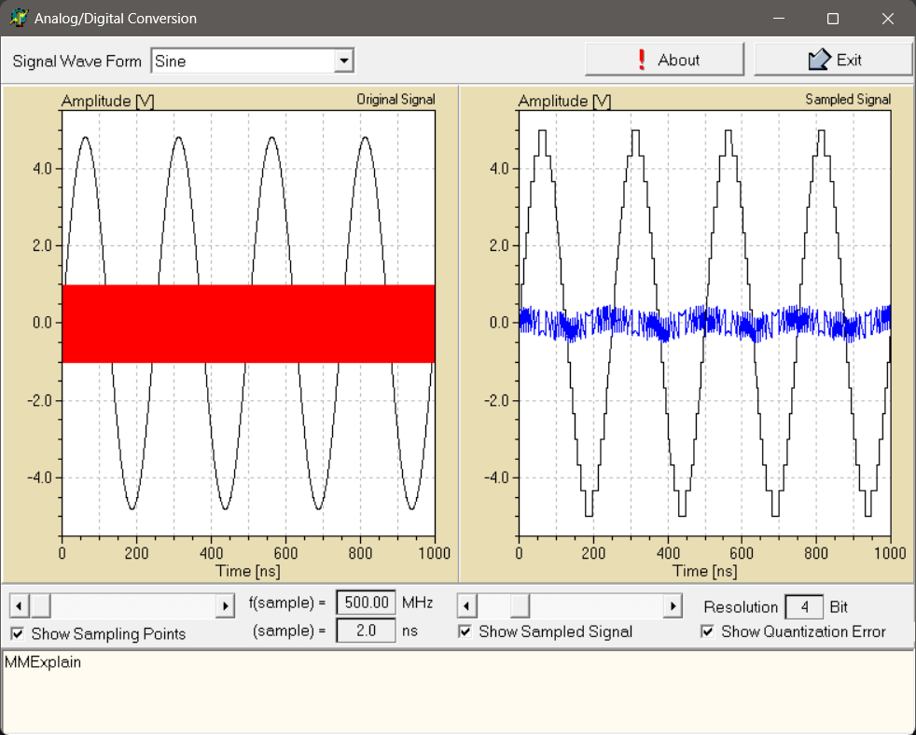

**Conclusions:**

**The Nyquist Rate shows that sampling at least 2 times the signal frequency prevents errors in depicting the sampling signal.**

**Sampling frequency being reduced can represent poor signal representation.**

**Quantization determines the detail level in the sampled signal, and the associated error arises from rounding the signal amplitude to discrete values. A higher bit resolution allows for finer representation and lower quantization error, while lower bit resolution results in greater quantization error and a more distorted signal.**